

Hello, I am Mbanefo Benedict Chibuike

I am passionate about data due to its enigmatic nature which fuels my curiosity. I firmly believe that behind every dataset lies an abundance of untapped knowledge which can change the world. One of my defining qualities is my unwavering dedication to continuous learning, constantly seeking new insights and expanding my horizons. When I'm not immersed in the world of data, you can find me indulging in my hobbies, which include football, music, leisure reading, and movies.

**My Past Projects**

**1.** [**Exploratory Data Analysis of Real Time Uber Data**](https://github.com/Chukwubuikexo/EDA-ON-UBER-DATA/blob/main/Uber_Data.ipynb)

A deep dive into the insights provided by recorded uber rides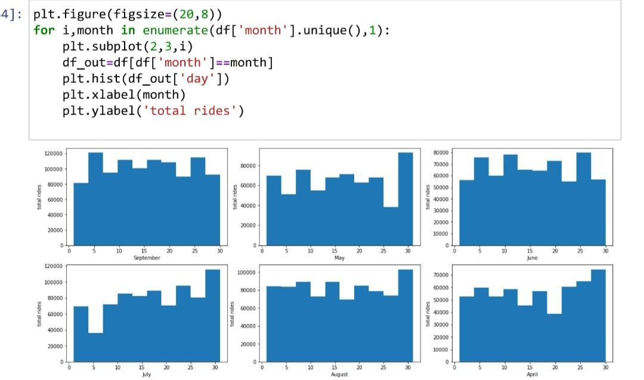

This project focuses on exploratory data analysis of real-time Uber data. I analyzed the data, providing valuable insights on ride patterns, peak hours, etc. This analysis can assist in optimizing operations, improving efficiency, and enhancing the overall user experience in the Uber ecosystem.

2. [**Data Cleaning on Clinical Dataset**](https://github.com/Chukwubuikexo/Clinical_data_test/blob/main/Clinical_data_test.ipynb)

Thorough cleaning and transformation of a dirty dataset

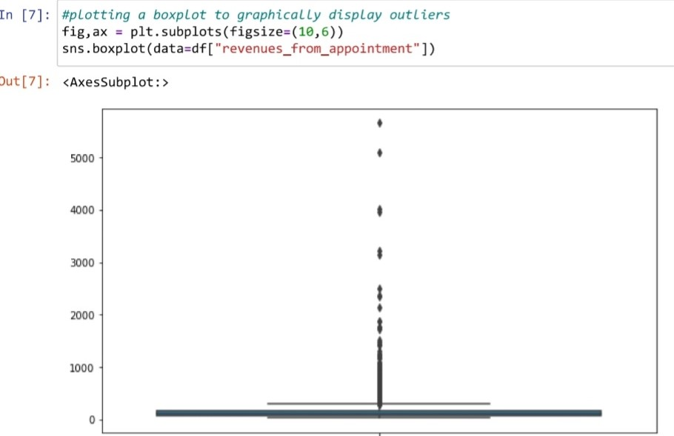

3. [**Prediction Model with Linear Regression**](https://github.com/Chukwubuikexo/Predicting-the-percentage-of-a-student-with-number-of-hours-studied/blob/main/Task%201.ipynb)

Predicting the percentage of a student with the number of hours studied.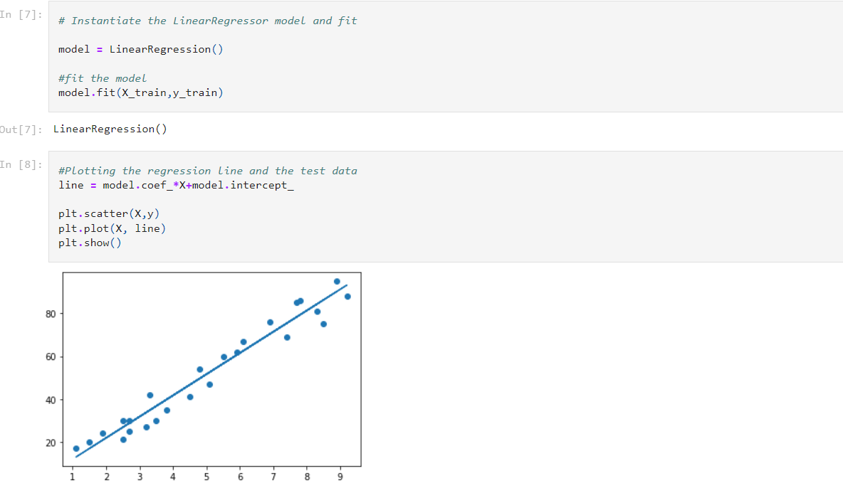

In this project, I built a model to predict the percentage of a student based on the number of hours studied. The data is analyzed using regression techniques to establish a relationship between study hours and percentage. The model undergoes training and testing phases to accurately predict the percentage for new students based on their study hours. By leveraging linear regression analysis, developed valuable insights into the impact of study hours on academic performance.

4. [**Predicting Heart Disease**](https://github.com/Chukwubuikexo/Predicting-heart-disease-with-ML/blob/main/end-to-end-heart-disease-classification.ipynb)

An end-to-end model built to predict heart disease using K-Neighbors Classifier, Logistic Regression, and Random Forest Classifier.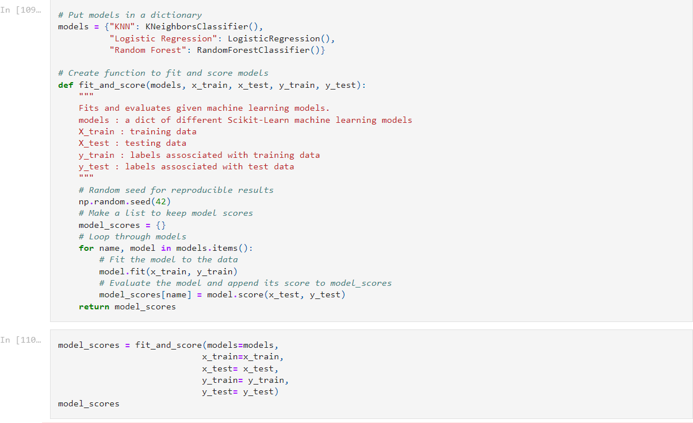

I built a model aimed to leverage the collective strength of three different algorithms to enhance prediction accuracy and provide valuable insights on healthcare data of over 300 entries. This model utilized three model, K-Neighbors Classifier, Logistic Regression, and Random Forest Classifier, and evaluators such as confusion_matrix, classification_report**t** precision_score, recall_score, f1_score

**Mini-Projects**

1. Unleashing the Power of Exploratory Data Analysis on [medium](https://chukwubuikexo.medium.com/unleashing-the-power-of-exploratory-data-analysis-fd00298119ad)